**ASSIGNMENT#2**

**Part I**

LAN & WAN Connection:

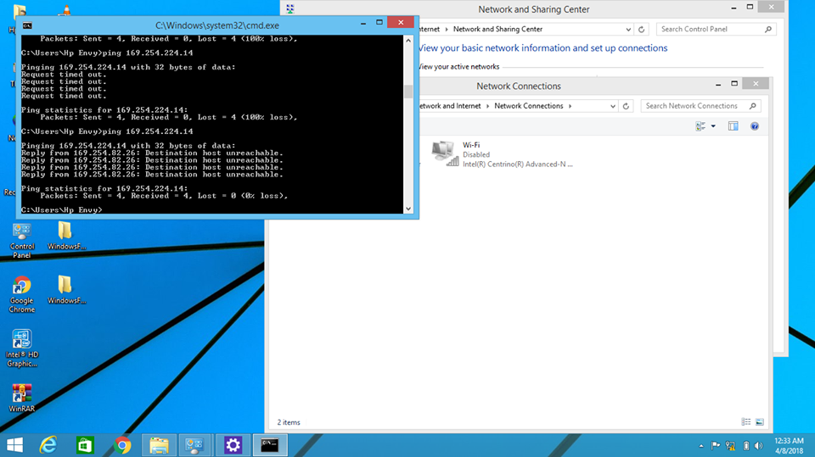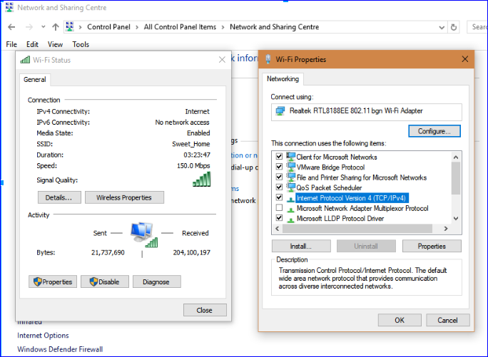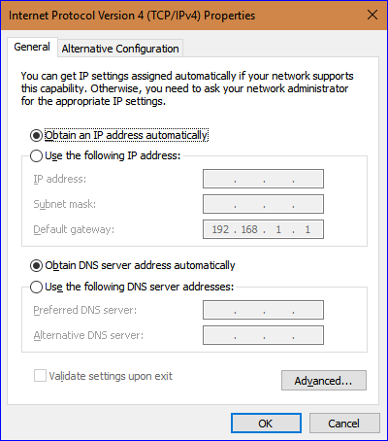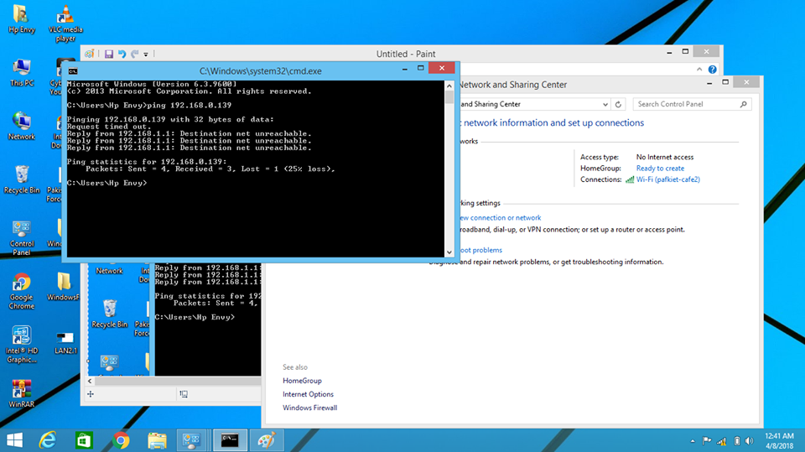

**Part II**

**ERROR CODES**



The HTTP 404, 404 Not Found and 404 error message is a Hypertext Transfer Protocol (HTTP) standard response code, in computer network communications, to indicate that the client was able to communicate with a given server, but the server could not find what was requested.  
The website hosting server will typically generate a "404 Not Found" web page when a user attempts to follow a broken or dead link; hence the 404 error is one of the most recognizable errors encountered on the World Wide Web.

**Overview:**

When communicating via HTTP, a server is required to respond to a request, such as a web browser request for a web page, with a numeric response code and an optional, mandatory, or disallowed (based upon the status code) message. In the code 404, the first digit indicates a client error, such as a mistyped Uniform Resource Locator (URL). The following two digits indicate the specific error encountered. HTTP's use of three-digit codes is similar to the use of such codes in earlier protocols such as FTP and NNTP.

A 404 error is often returned when pages have been moved or deleted.

Temporary Error 14

If you ever get "Temporary Error 14" in your Yahoo Mail account, don't worry, it's nothing you did. While the error will usually correct itself on its own, here's a workaround that can help get you up and running quicker.

## Workaround

1. Sign out of Yahoo Mail on all desktop and mobile devices.
2. Clear your Web browser's cache.
3. Restart your Web browser.
4. Sign back in to Yahoo Mail.